30mph Traffic & Speed Signage Assessment in Stoke Village – 28th March 2014
Sarah Cooney and Michael Widén

1. Introduction

This report contains 14 recommended changes to road signage to assist in the enforcement of the 30mph speed limit along (and on access roads to) the B3048 from Stoke to St Mary Bourne. The report has been made in consultation with the local Speedwatch team of volunteers which operates along this stretch of road. The recommendations include removing existing erroneous and misleading signage, repainting faded road signage, and incorporating new signage.

All of the recommendations have been carefully considered with the objective of making the 30mph speed limit more visible and signage more impactful. In spite of the Speedwatch team being in operation for over 18 months now, there are still many incidences involving drivers exceeding the 30mph speed limit, with some driving in excess of 45mph. The volunteer team feel strongly that poorly visible and misleading signage is contributing to this situation and that it needs to be made clearer.
2. Recommendations
The sequence of recommendations starts at the 30mph restriction entrance to Stoke Village from the north, continues south through Stoke and St Mary Bourne villages, and finishes at the end of the 30mph limit of St Mary Bourne near to the watercress beds. The accompanying map shows which point in the road each recommendation refers to.

 | Comments | Photo of Existing Signage | Example of Recommendation
1. | 30mph limit entry southbound towards Stoke Village.  The signs need replacing as they are damaged. The 30mph signs are sited in a double bend losing impact. Cars typically do not slow down to 30 here, causing a hazard at Jones (Pontings) Farm where farm vehicles are joining the main road.  Recommendation is to replace damaged signs, put in a red tarmac strip across both carriageways with a 30 roundel on the southbound side.  Also to site rumble strips south of this point to raise awareness of high speeds as vehicles pass the farm entrance. | 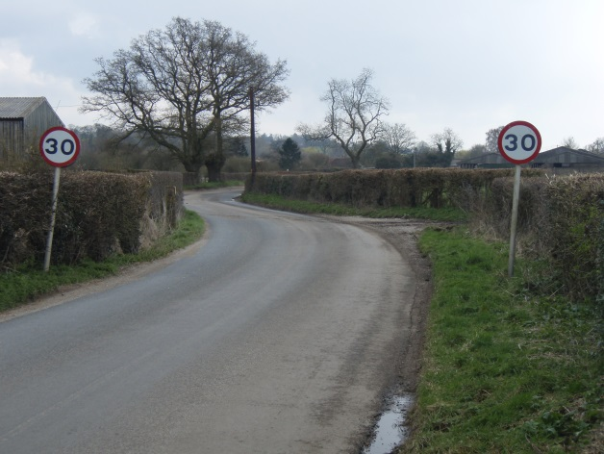 | 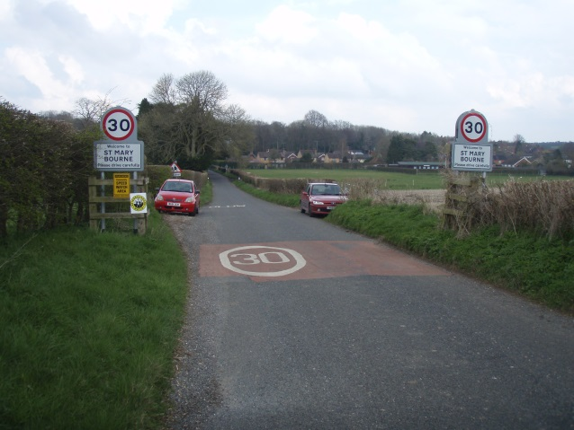
2. | SLOW sign in road by Jones (Pontings) Farm needs repainting. | 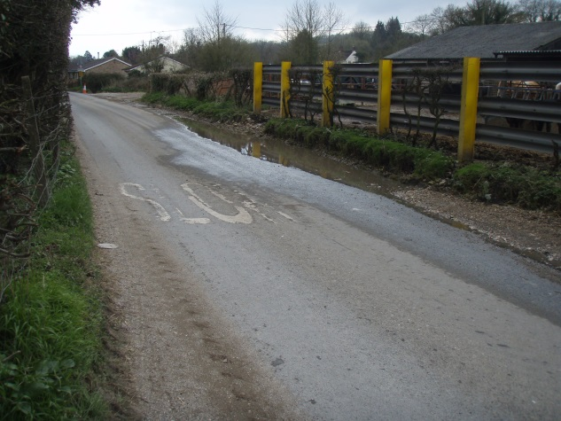 | N/A
3. | Northern entrance/exit to Stoke Village.  The northern entrance/exit to Stoke Village is not prominent enough - the Stoke sign is small and is accompanied with only a repeater 30 sign.  Recommendation is to place a 30 roundel on both carriageways on plain tarmac; secondly to put a village ‘gate’ around the sign similar to those in SMB. Also to consider a larger Stoke sign to increase visibility as you enter the village. | 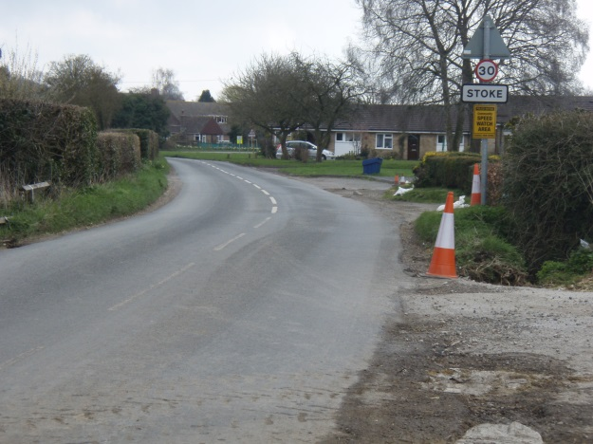 | 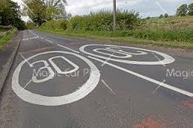
4. | Entrance to Stoke Village from Smannell.  This road is busy with traffic coming over from the new estate in Andover. The hill is steep and the signs get lost behind foliage in the height of summer.  Recommendation is to put in a red tarmac strip across both carriageways with a 30 roundel on the Stoke-bound side. | 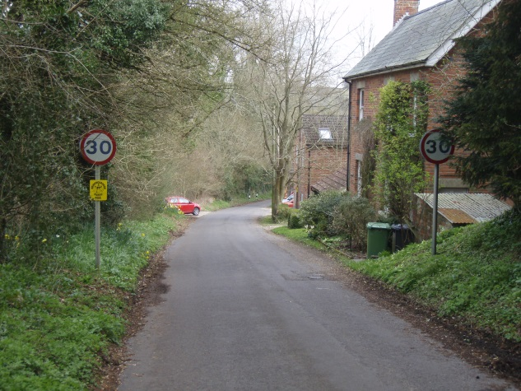
5. | Entrance to Stoke Village from Binley.  This road is busy with traffic using this as a shortcut between the A343 & B3048 via Doiley Bottom. The hill is steep and the signs get lost behind foliage in the height of summer.  Recommendation is to put in a red tarmac strip across both carriageways with a 30 roundel on the Stoke-bound side. | 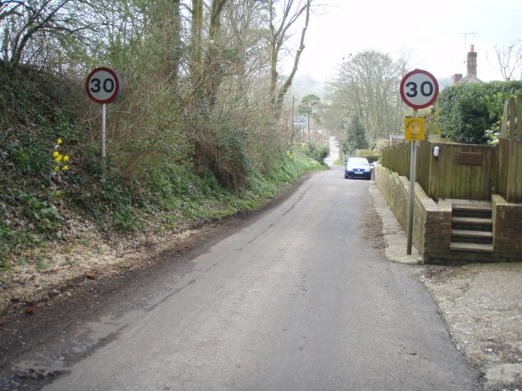
6. | Northbound in Stoke by Playground sign.  Immediately after this is the left hand turning to Smannell, followed by the Playground on the right. Speeding cars weave between parked cars on this stretch of the road.  Recommendation is to paint SLOW on the northbound carriageway.  Also, from the other direction, the repeater 30 on the back of the pole is partially hidden by the telegraph pole. | 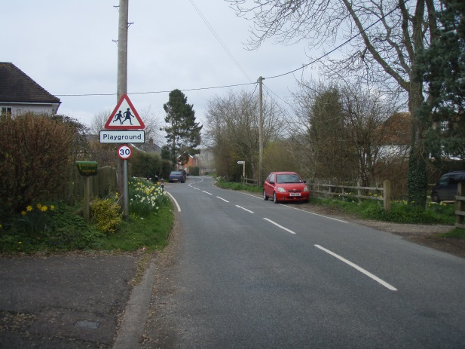 | 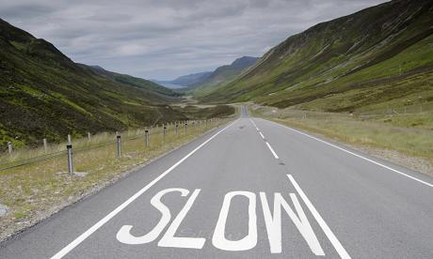
7. | Southern entrance/exit to Stoke Village  The southern entrance/exit to Stoke Village is not prominent enough a small Stoke sign with a repeater 30 sign on the opposite side of the road.  Recommendation is to place a 30 roundel on both carriageways on plain tarmac. Secondly to put a village ‘gate’ around the sign similar to those in SMB. | 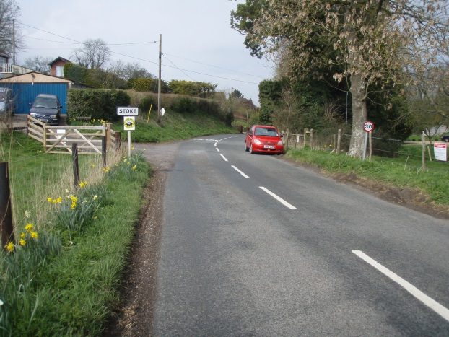
8. | Stretch between Stoke Village and Gangbridge Lane.  This is a relatively long stretch with few repeater signs that get lost in foliage in the summer months. Cars frequently overtake each other here exceeding the 30mph limit.  Recommendation is to place a 30 roundel on both carriageways on plain tarmac by the 30 repeater sign. This will reinforce that the 30mph speed limit applies between Stoke and SMB. | 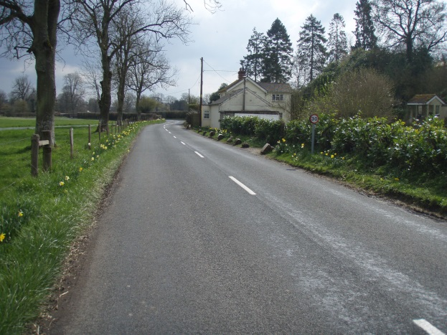
9. | North of Gangbridge Lane.  The entrance to Gangbridge Lane here is hidden and near misses have occurred when cars and lorries pull out onto the B3048 into the path of speeding southbound cars.  Recommendation is to paint a SLOW sign on the southbound carriageway by the repeater sign. | 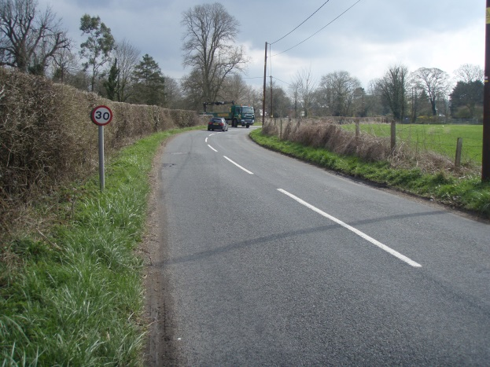
10a. | Northern Entrance/Exit to SMB Village.  This used to be the old 30mph de-restriction limit. The road marking are currently erroneous and misleading.  Recommendation is to paint a 30mph roundel on the northbound side too. | 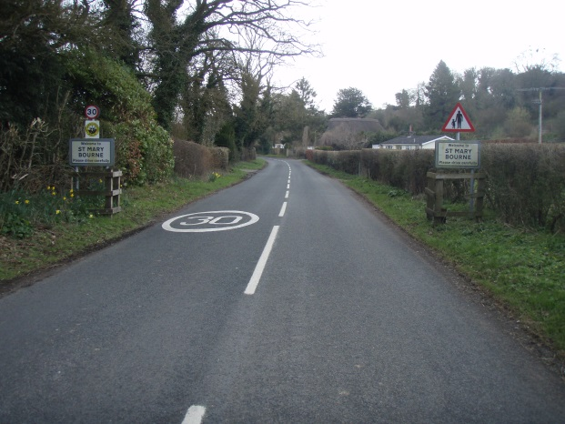
10b. | Northern Entrance/Exit to SMB Village.  This used to be the old 30mph derestriction limit. The ‘Thank you for Driving Carefully’ sign on the northbound side gives the false impression that the 30mph is being lifted north of this point.  Recommendation is to remove the ‘Thank You for Driving Carefully’ sign on the northbound side. | 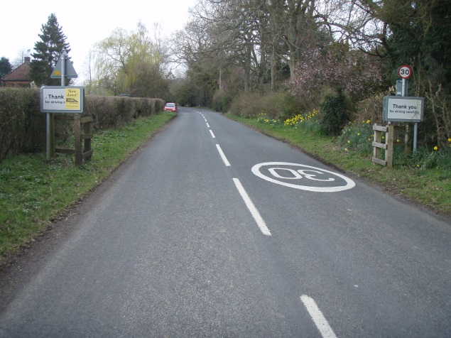 | N/A
11. | Approaching SMB School – Southbound.  Another place where cars travel at speed. While the School warning sign helps, there are no road markings at this point to reinforce the speed limit.  Recommendation is to paint a SLOW sign on the southbound carriageway by the School sign. | 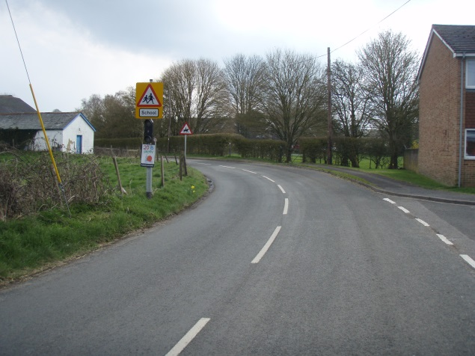
12. | Entrance to SMB from Upper Wyke down to the War Memorial.  Recommendation is to refresh the road markings which are worn away. |  | N/A
13. | Egbury Road entrance to SMB.  This entrance is subject to a separate review through the Long Term Plan.  Even so, the recommendation is that the red strip and road markings are refreshed. If the 30mph is moved up to the Pick Your Own, then a second 30 roundel needs painting on the outbound carriageway to reinforce that the 30mph limit continues. | 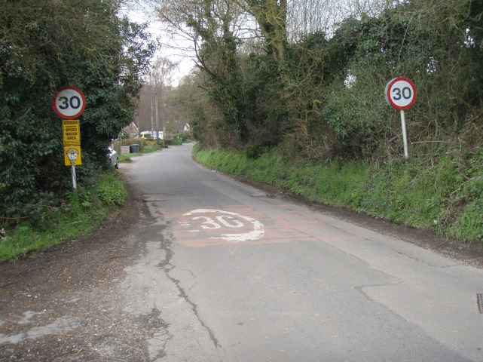 | N/A
14. | Old derestriction limit south of SMB Village.  The 30 roundel on the carriageway remains from when the old derestriction limit was here. This is misleading as cars heading south could interpret this as the end of the 30 limit.  Recommendation is to paint another 30 roundel on the southbound side. | 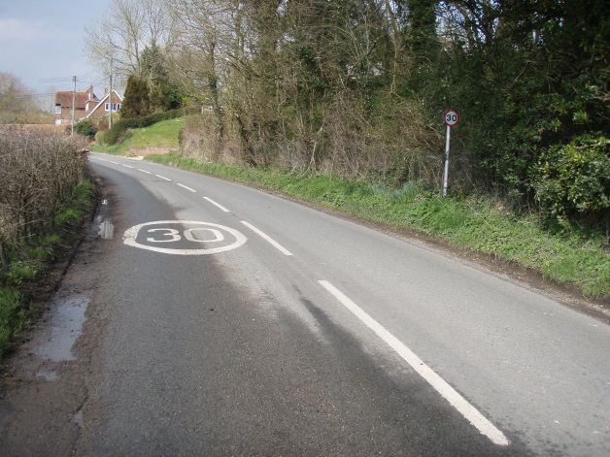
15. | South of the Bourne Valley Inn.  This is a straight stretch of road which we monitor through Speedwatch. High levels of speeding occur here and signage is minimal.  Recommendation is to place a 30 roundel on both carriageways on plain tarmac by the 30 repeater sign. This will reinforce that the 30mph speed limit applies south of SMB Village. | 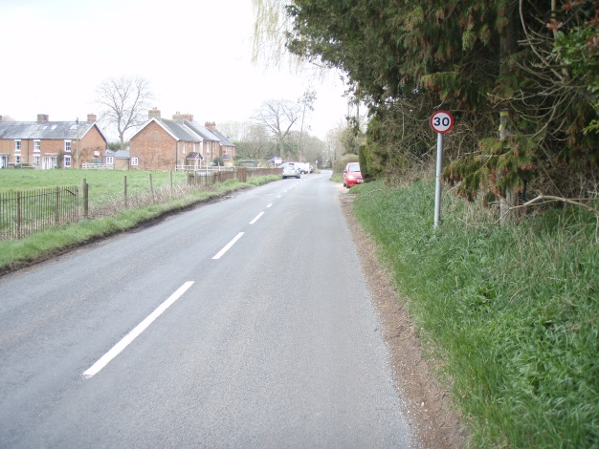
16. | Southern entrance/exit to 30mph limit.  Recommendation is to put in a red tarmac strip across both carriageways with the 30 roundel on the southbound side.  Also to site rumble strips north of this point to raise awareness of high speeds approaching residential dwellings and the Bourne Valley Inn. | 